Tutorial 10

Module Name: Automation & Regression Testing
Test Case ID: TC10
Tester Name: Vora Riya

Scenarios:
- Scenario ID: REG01
Scenario
Verify login functionality
Test Steps
1. Open SauceDemo.
2. Enter valid credentials.
3. Click Login.
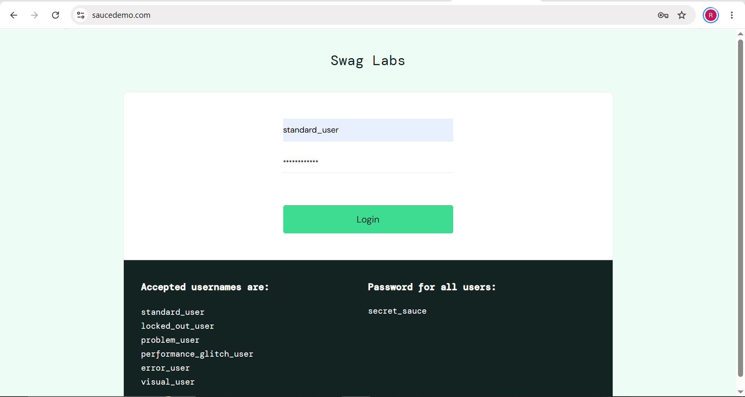

- Scenario ID: REG02
Scenario
Verify product display
Test Steps
1. Log in.
2. Inspect the inventory page.
3. Verify product names, prices and images.
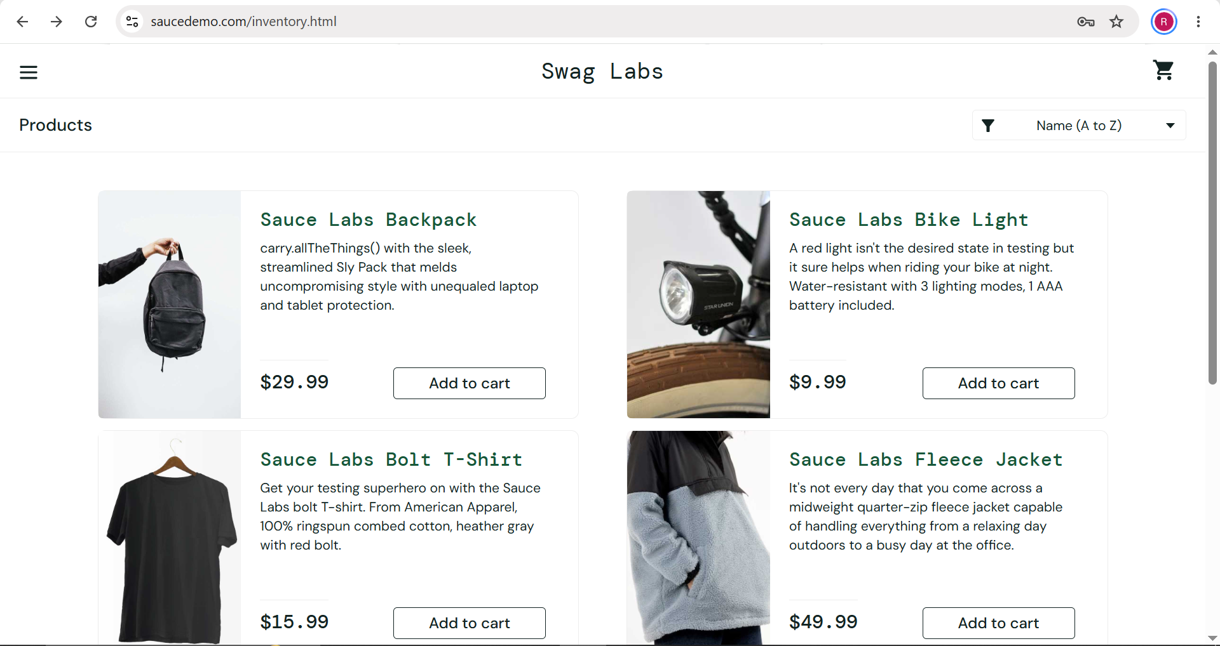

- Scenario ID: REG03
Scenario
Verify adding a product to the cart
Test Steps
1. Log in.
2. Select a product.
3. Click Add to cart.
4. Open the cart.
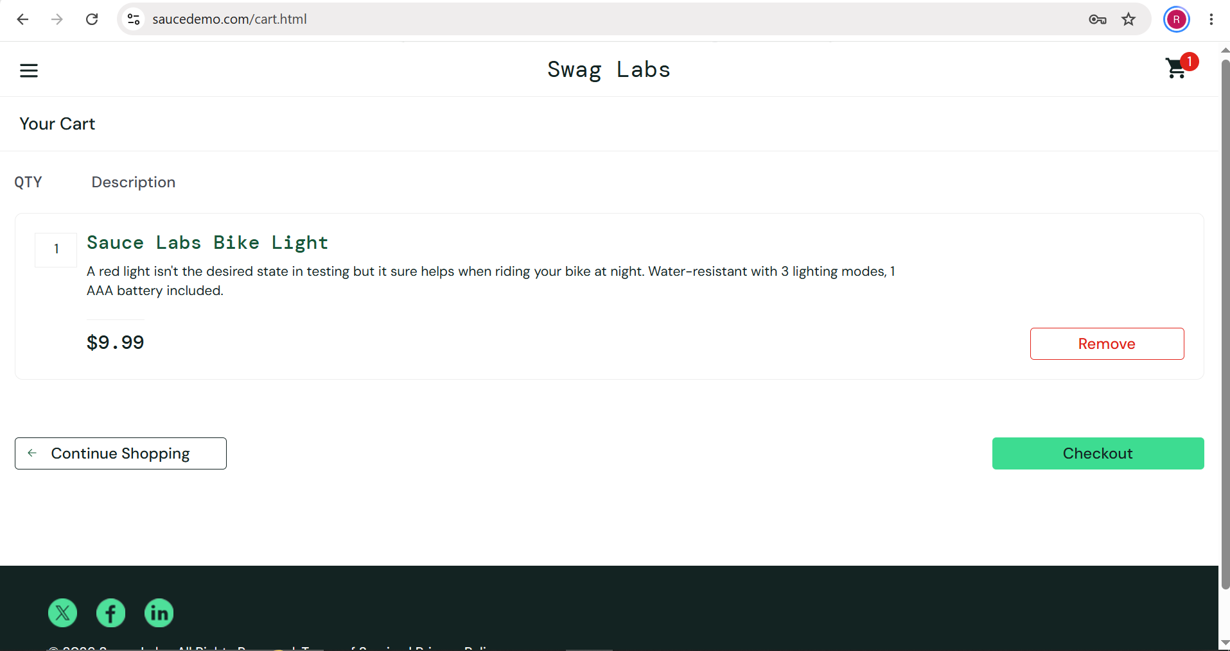

- Scenario ID: REG04
Scenario
Verify removing a product from the cart
Test Steps
1. Add a product to the cart.
2. Open the cart.
3. Click Remove.

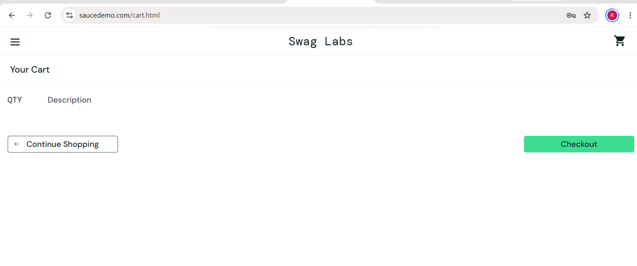

- Scenario ID: REG05
Scenario
Verify checkout functionality
Test Steps
1. Log in.
2. Add a product.
3. Open cart.
4. Click Checkout.
5. Enter required customer information.
6. Continue and finish the order.

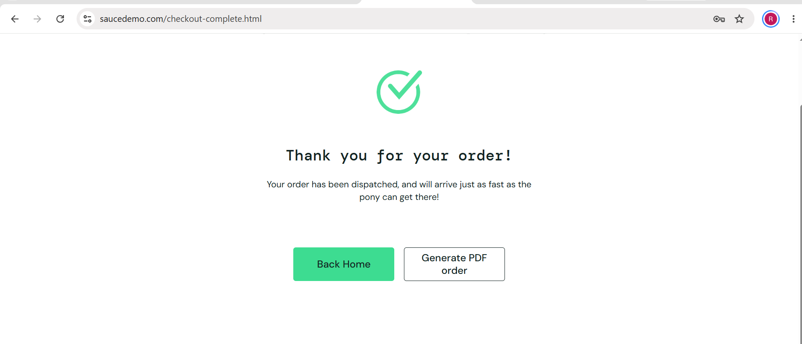

- Scenario ID: REG06
Scenario
Verify logout functionality
Test Steps
1. Log in.
2. Open the menu.
3. Click Logout.

